[](http://www.google.com.au/imgres?sa=X&hl=en&biw=1920&bih=931&tbm=isch&tbnid=6wOImh1MHXJipM:&imgrefurl=http://www.quick-weight-loss-tips-for-women.com/deep-breathing-exercises.html&docid=V3MlgI5NcbCMDM&imgurl=http://www.quick-weight-loss-tips-for-women.com/image-files/qwltfwnew77.jpg&w=448&h=331&ei=1c6aUZWSBY3rkgXyiYH4BA&zoom=1&ved=1t:3588,r:48,s:0,i:300&iact=rc&dur=875&page=2&tbnh=193&tbnw=261&start=32&ndsp=43&tx=58&ty=103)**Year 8 Biology Investigation**

Your body systems do not work independently. Each one relies on and affects the other.

Your task is to determine how breathing rate and heart rate are related.

[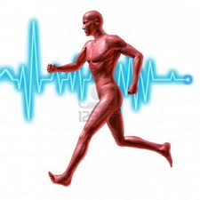](http://www.google.com.au/imgres?start=117&um=1&hl=en&biw=1920&bih=931&tbm=isch&tbnid=2XAgZp4n492F7M:&imgrefurl=http://www.123rf.com/photo_10503735_exercise-and-fitness-symbol-represented-by-a-jogging-human-with-a-heart-rate-monitor-life-line-showi.html&docid=kxF_9U5w0B1ziM&imgurl=http://us.123rf.com/400wm/400/400/lightwise/lightwise1109/lightwise110900098/10503735-exercise-and-fitness-symbol-represented-by-a-jogging-human-with-a-heart-rate-monitor-life-line-showi.jpg&w=1200&h=1200&ei=rq6ZUYHlEeTYigecpoCgCA&zoom=1&ved=1t:3588,r:41,s:100,i:127&iact=rc&dur=1894&page=4&tbnh=203&tbnw=202&ndsp=41&tx=156&ty=109)Your group will need to work out a way to either increase or decrease breathing or heart rate and see what happens to the other.

Some options you could try are:

* exercise to increase the heart rate
* a period of slow deep breathing

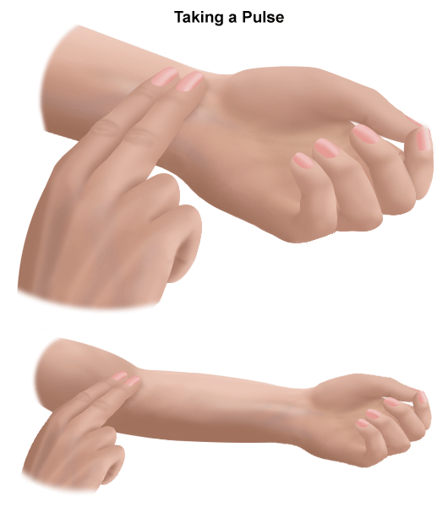

You will need to repeat the experiment 2-4 times and obtain an average. Remember that you only place the average results in your graph.

It is very important to control your variables in this experiment and to explain how you did this clearly in your method.

It is also important to do some research to see if you can find scientific reasons for your results and explain these in your conclusion.

*Pearson Science 8 Pg 107 describes how to take a pulse*

|  |  |  |  |
| --- | --- | --- | --- |
| **Part**  *These should form subheadings in your work* | **Details** | **Available**  **mark** | **Your**  **mark** |
| **Title** | Descriptive NOT Biology Investigation | 1 |  |
| **Aim** | Why are you doing this experiment? What do you want to find out? | 1 |  |
| **Introduction** | Background scientific information eg what are the functions of the circulatory and respiratory systems? | 2 |  |
| **Hypothesis** | Correctly worded  Includes dependent and independent variables | 2 |  |
| **Independent Variable** | The variable I change (I for independent). When you change the independent variable the variable you are measuring (the dependent variable) will probably change too. | 1 |  |
| **Dependent Variable** | The variable you are measuring. Any change in this variable depends on what you do to the independent variable. | 1 |  |
| **Controlled Variables** | All the things you keep the same to make it a fair test. You should usually list at least three. | 2 |  |
| **Materials** | Complete  Listed  Detail eg 25g of salt or 3 x 250ml beakers | 2 |  |
| **Method** | * Step by step with numbers * Written in past tense * Complete * Labelled Diagrams * Explain how reliable results are achieved. Trials/replicates? How did you control your controlled variables? | 1  1  1  2  2 |  |
| **Results** | Table - neat & clear with units | 3 |  |
| **Graph** | Includes title, labels on each axis, correct units, regular spaced, legend for each line graph. Use a ruler, do it in pencil and make it neat | 5 |  |
| **Discussion** | * What did your results show? Use numbers * Errors * Effects of errors on results * Solutions | 4 |  |
| **Conclusion** | * What did the results show? Is there a trend * Does this support your hypothesis? * Scientific reasons – YOU NEED TO DO SOME RESEARCH FOR THIS PART | 1  1  3 |  |
| **References** | Will usually include your text book and at least one other source.  See your diary for correct setting out | 2 |  |
| **Total mark** | | **38** |  |